7/29 Class Notes

Section 9.6 Shortest-Path Problems

Homework pages: 655 – 657 #3, 5, 11, 17, 25, 27

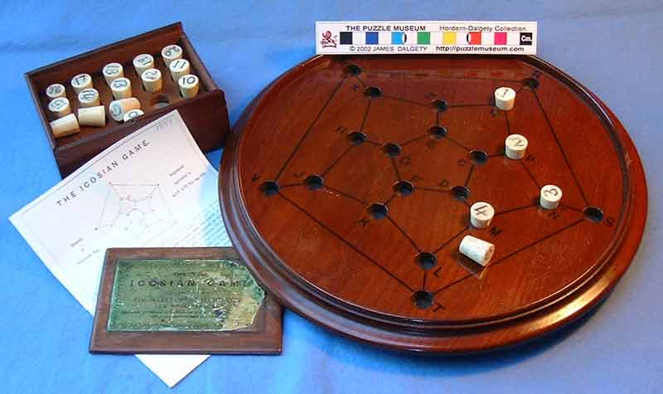

Example of a weighted graph

Example: Give the shortest path between a and z in the graph:

The Nearest Neighbor Method, Also known as Dijkstraz’ algorithm.

The Brute Force Method:

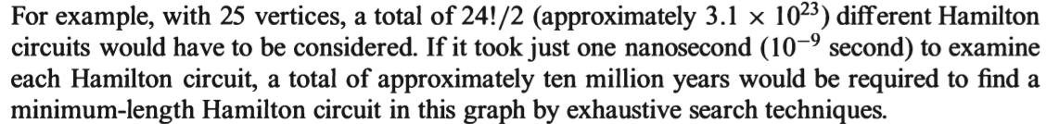

Example: Find the lengths of all Hamilton circuits in the problem below and choose the shortest circuit.

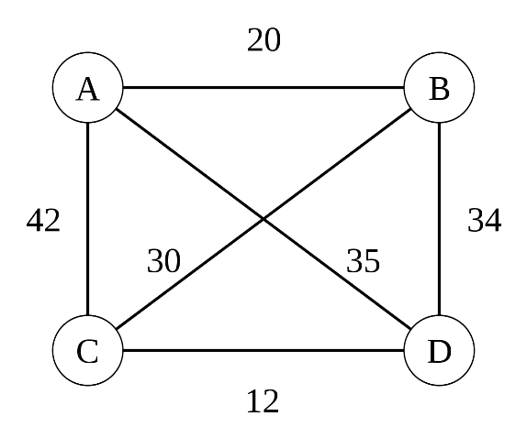

9.8 Graph Coloring

Homework Pages 672 – 675 # 1, 3, 5, 7, 10, 17.

Make dual graphs to each Map.

Color the vertices of the graph so that no two adjacent vertices have the same color.

What is the minimum number of colors you can use?









Applications to graph coloring: Scheduling:

How many time slots can be created to schedule final exams if the vertices of the graph represent the courses and two courses are adjacent if a student is enrolled in both classes.

Example:

What is the chromatic number of K5? C5?